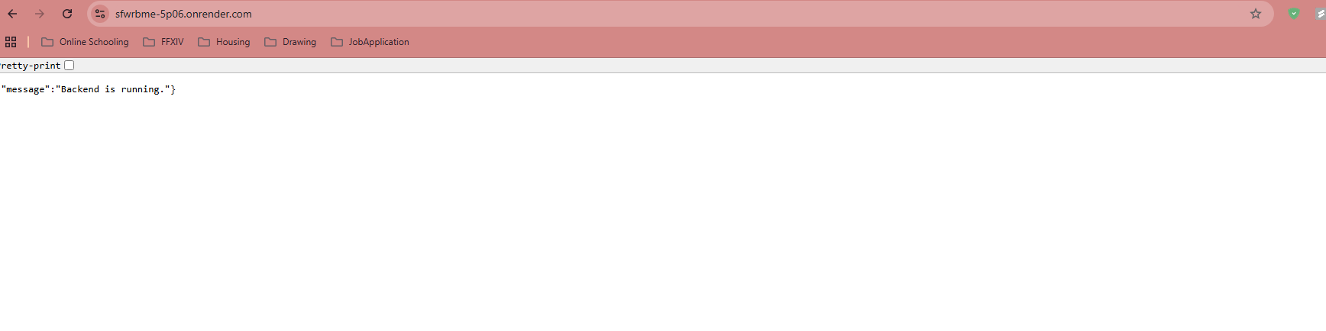
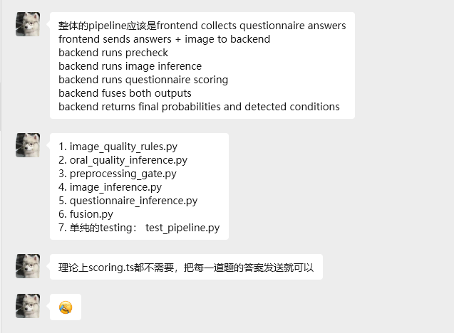
Mock Test from phone app to backend api
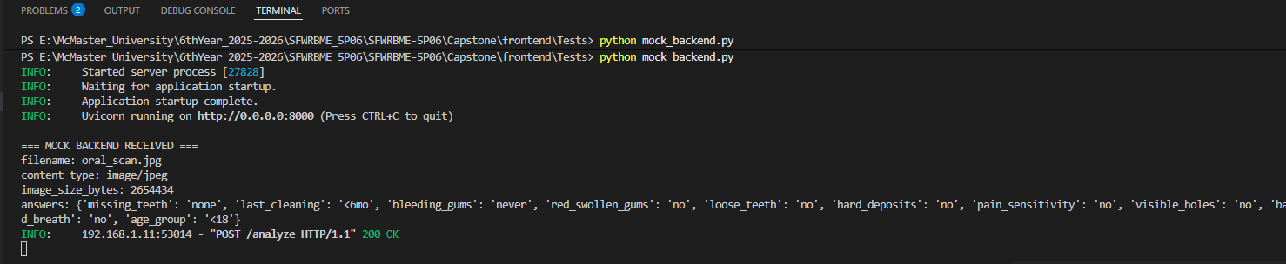
Minimal test matrix you can use immediately
You can literally use this:
Test | Expected Result
Valid image + complete questionnaire | Successful submission and result shown
No image taken | User blocked
Incomplete questionnaire | User blocked can not progress
Backend offline | Error alert shown
Malformed backend response | Graceful failure, no crash
Missing result params | Fallback screen shown
Double tap submit | Only one submission
Retake image before submit | Latest image used
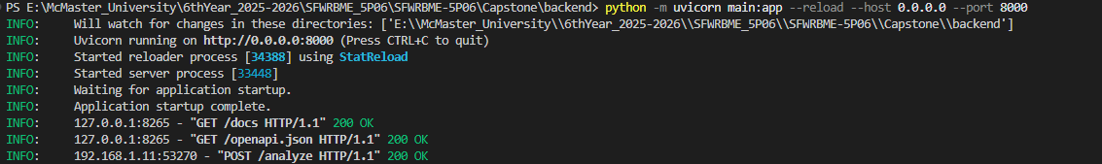
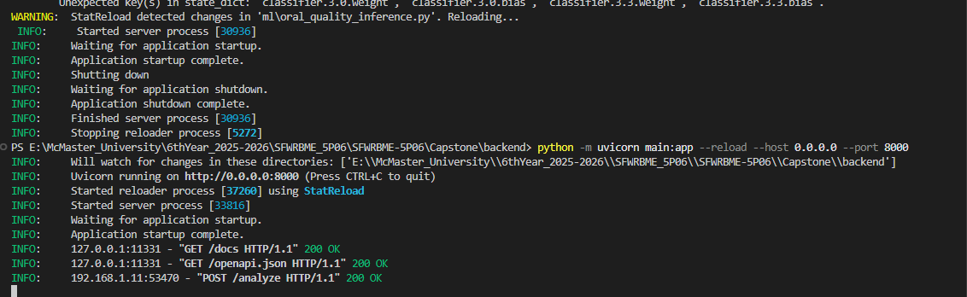
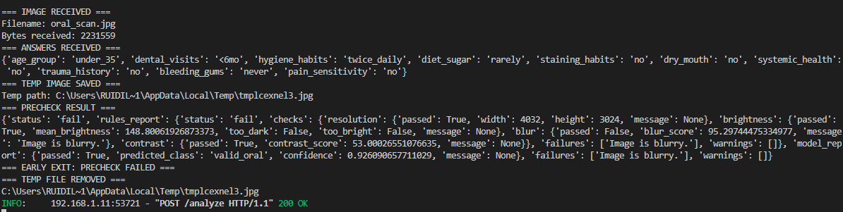
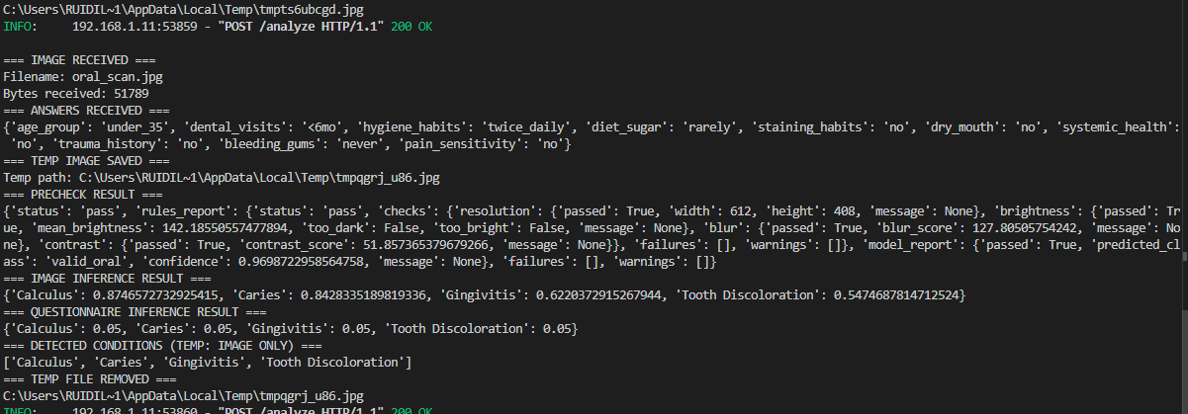


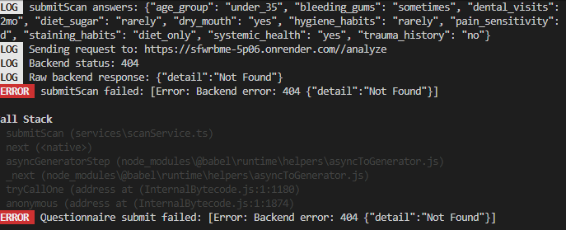
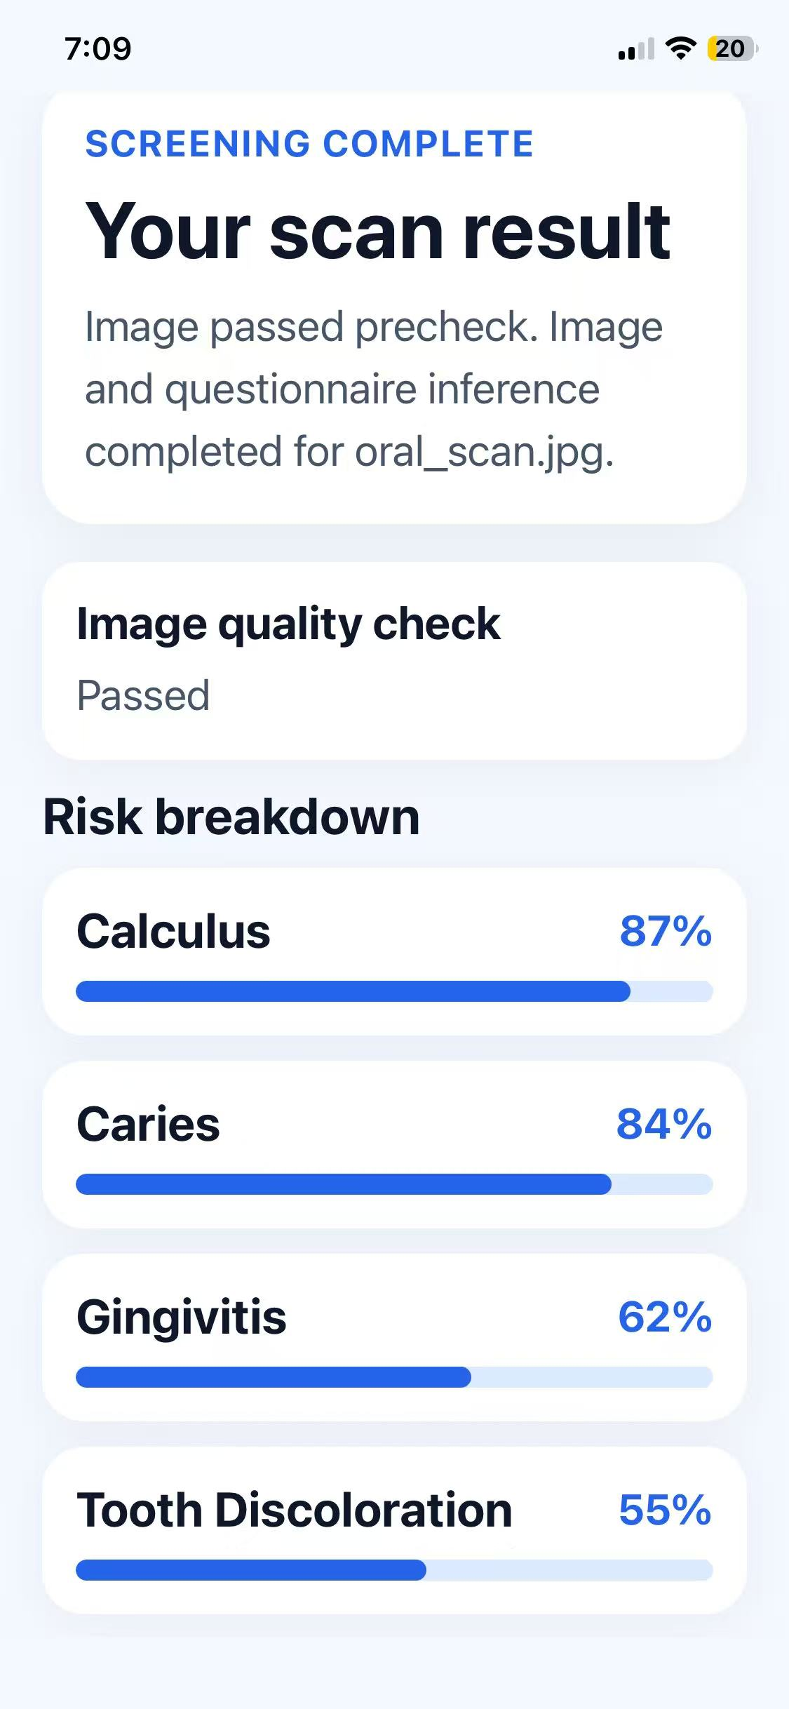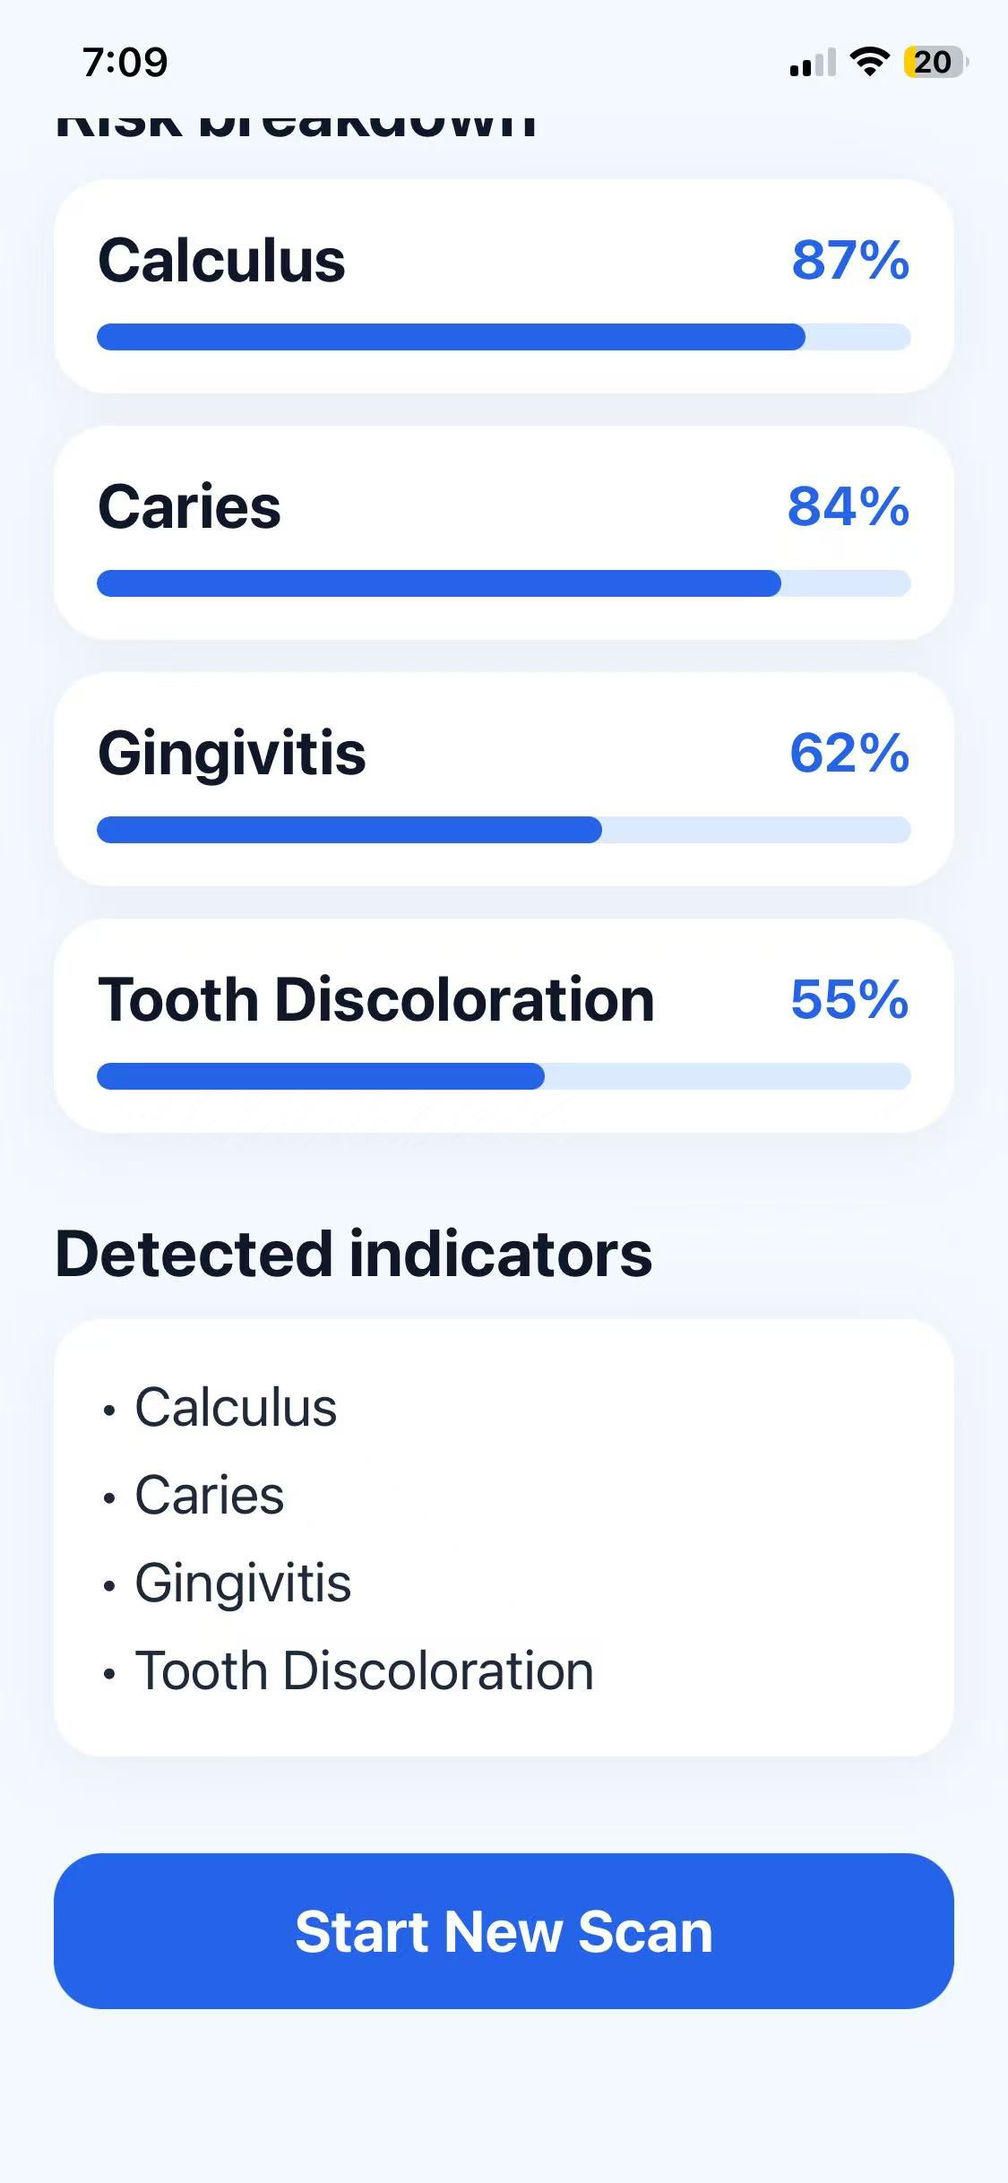
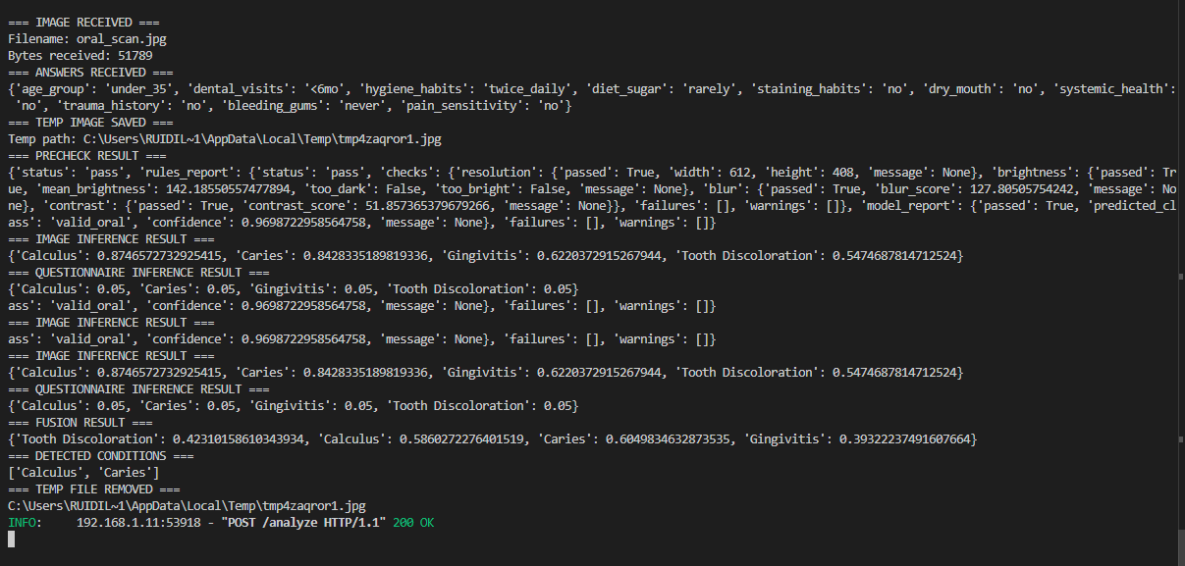
TLS During local development, the frontend communicates with the FastAPI backend over a local network HTTP endpoint. In deployment, this endpoint is intended to be replaced by an HTTPS endpoint secured with TLS 1.3.
